**Chapter 8**

**Bifurcations Revisited**

This chapter extends our earlier work on bifurcations (chapter 3).

**Saddle node, Transcritical and Pitchfork Bifurcations**

**Saddle Node Bifurcation :**

The saddle node bifurcation is the basic mechanism for the creation and destruction of fixed points. Here’s the prototypical example in two dimensions:

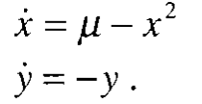

In the x direction we see the bifurcation behaviour is discussed in chapter 3, while in the y-direction the motion is exponentially damped.

Consider the phase portrait as 𝞵 varies :

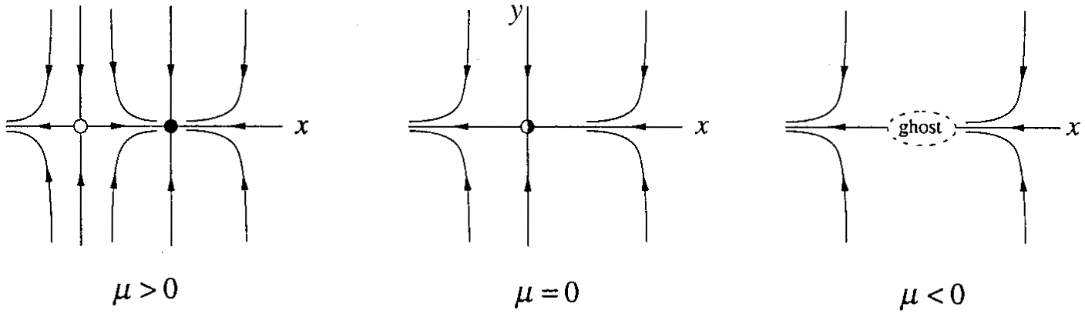

**Transcritical and Pitchfork Bifurcations :**

In the x-direction the dynamics are given by the normal forms discussed in chapter 3, and in the y direction the motion is exponentially damped. This yields the following examples :

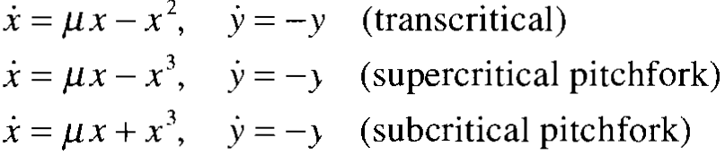

The analysis in each case follows the same pattern, so we will discuss only the supercritical pitchfork bifurcation.

The phase portraits for supercritical pitchfork as 𝝁 varies :

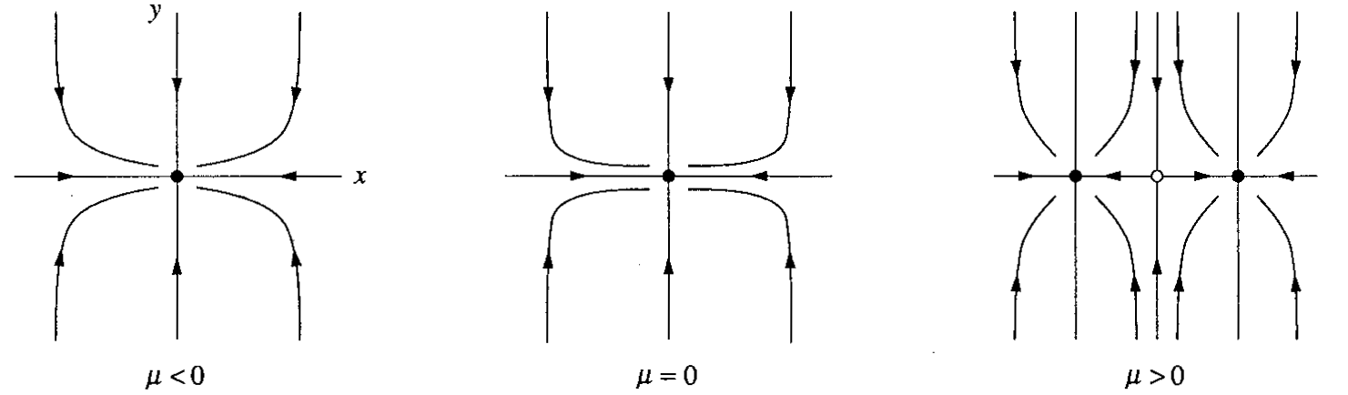

**Hopf Bifurcations :**

Suppose a two-dimensional system has a stable fixed point. What are the possible ways it could lose stability as a parameter varies? The eigenvalues of the Jacobian are the key. If the fixed point is stable, the eigenvalues 𝝀1 and 𝝀2 must both lie in the left half-plane Re 𝝀 <0 . Since the 𝝀’s satisfy a quadratic equation, there are two possible pictures: either the eigenvalues are both real and negative or they are complex conjugates. To destabilize

the fixed point, we need one or both of the eigenvalues to cross into the right half plane as 𝝁 varies.

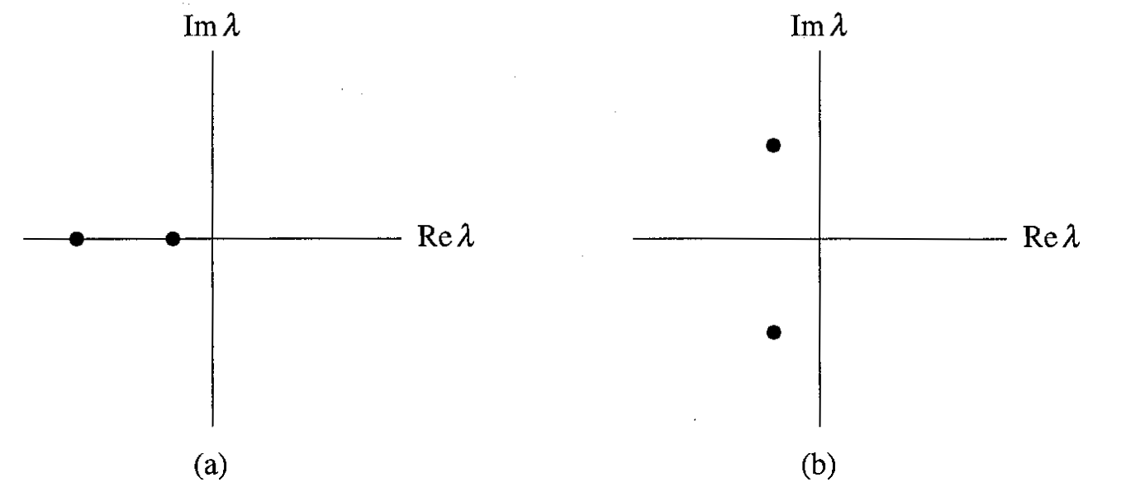

Now we consider the case in which two complex conjugate eigenvalues simultaneously cross the imaginary axis into the right half plane.

**Supercritical Hopf Bifurcation:**

Suppose we have a physical system that settles down to equilibrium through exponentially damped oscillations. Now suppose the decay rate depends on a control parameter 𝝁. If the decay becomes slower and slower and finally changes to growth at a critical value 𝝁c, the equilibrium will lose stability. Then we say that the system has undergone a supercritical Hopf bifurcation.

A simple example is given by the following system:

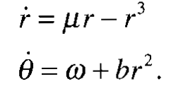

There are 3 parameters : 𝝁 controls the stability of fixed point at the origin, 𝟂 gives the frequency of infinitesimal oscillations, and b determines the dependence of frequency on amplitude for larger amplitude oscillations.

The corresponding phase portraits are :

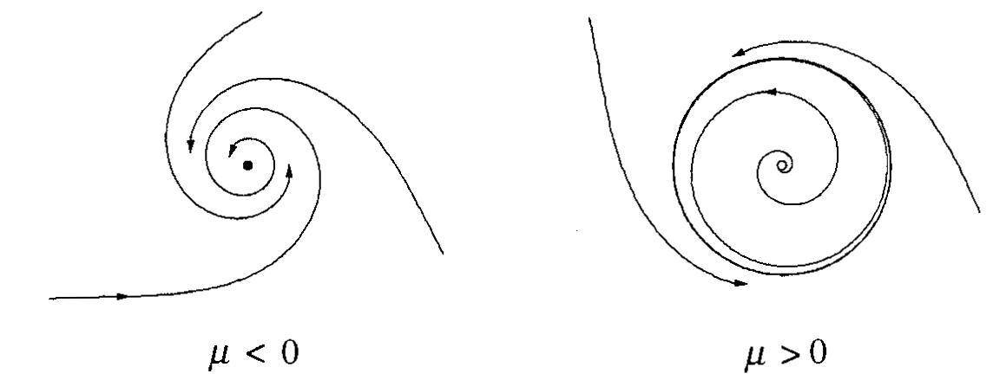

**Subcritical Hopf Bifurcation**

Just like pitchfork, Hopf bifurcations come in both super and subcritical varieties.

Consider the two dimensional example :

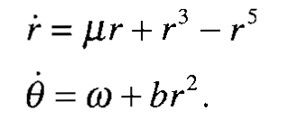

The important difference from the earlier supercritical case is that the cubic r⌃3 term is now destabilizing; it helps to drive trajectories away from origin. The phase portraits for 𝝁<o and 𝝁>0 are shown below:

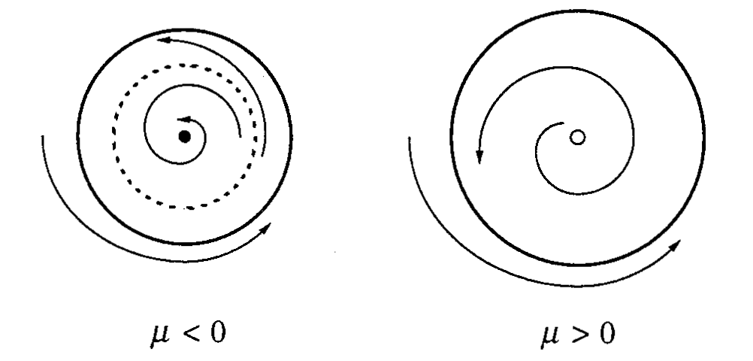

As 𝝁 increases, the unstable cycle tightens like a noose around the fixed point. A subcritical Hopf bifurcation occurs at 𝝁=0, where the unstable cycle shrinks to zero amplitude and engulfs the origin, rendering it unstable.

**Degenerate Hopf Bifurcation:**

An example is given by the damped pendulum:



As we change the damping 𝝁 from positive to negative, the fixed point at the origin changes from a stable to unstable spiral but it is NOT a true Hopf bifurcation because there are no limit cycles on either side of the bifurcation.

This degenerate case typically arises when a nonconservative system suddenly becomes conservative at the bifurcation point.

**Oscillating Chemical Reactions**

**Belousov’s “Supposedly Discovered Discovery”**

* In 1950’s, this was accidentally discovered while a scientist was trying to create a test tube caricature of the Krebs Cycle. This was the  first reaction, which was observed oscillating.
* This reaction is thought to involve more than twenty elementary reaction steps, utmost of them equilibrate rapidly, as thus kinetics is reduced to just three differential equations.

**Chlorine Dioxide-Iodine-Malonic Acid Reaction**

* The following three reactions and empirical rate laws capture the behaviour of the system:

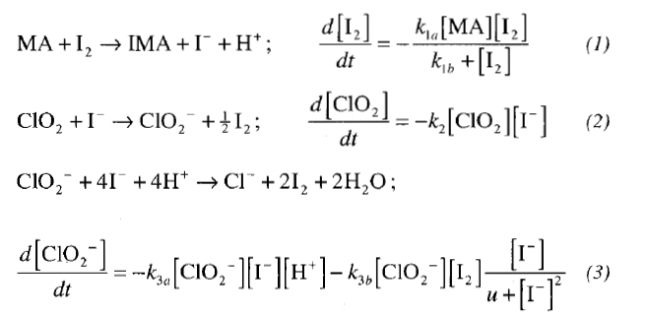

* Numerical integrations of (1)-(3) show that the model exhibits oscillations that closely resemble those observed experimentally.
* This model is a little complex to handle analytically. To simplify it, the scientists used a result found in their simulations: Three of the reactants(MA, I2, and ClO2) vary much more slowly the intermediates I- and ClO2-, which change by several orders of magnitude during an oscillating period. By approximating the concentrations of the slow reactions as constants and making other reasonable simplifications, they reduce the system to a two-variable model. After suitable nondimensionalization, the model becomes:

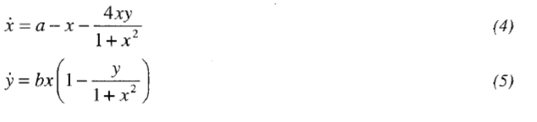

Where x and y are the dimensionless concentrations of I- and ClO2-.The parameters a,b>0 depend on the empirical rate constants and on the concentrations assumed for the slow reactions.

**Global Bifurcations of Cycles**

* Among the four ways in which limit cycles are created or destroyed, three comprises of global bifurcations. They are called so, since, they involve large regions of the phase plane rather than just the neighbourhood of a single fixed point.

**Saddle-node Bifurcation of Cycles**

* A bifurcation in which two limit cycles coalesce and annihilate.
* An example is:

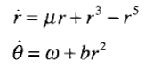

The first equation could be  regarded as a one-dimensional system. This, system      undergoes saddle-node bifurcation of fixed point at c= 1/4. Now returning to the two-dimensional system, these fixed points correspond to the circular limit cycles. The plots of the “radial phase portraits” and the corresponding behaviour in the phase plane are:

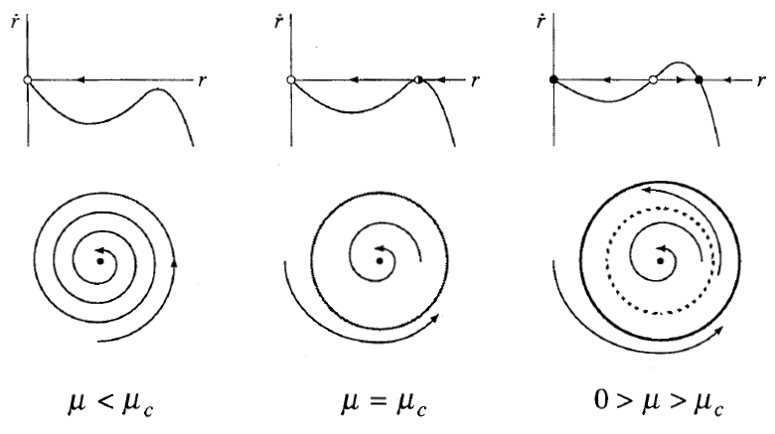

At a half-stable cycle is born out. As increases it splits into a pair of limit cycles, one stable and one unstable. Viewed in other direction, a stable and unstable cycle collide and disappear as decreases through c. Origin remains stable throughout; it does participate in this bifurcation.

**Infinite-period Bifurcation**

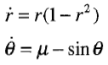

* This system combines two one-dimensional systems. In the angular direction, the motion is everywhere counterclockwise if >1, whereas there are two invariant rays defined by sin = if <1.Hence, as decreases through c=1, the phase portraits change as the following figure:

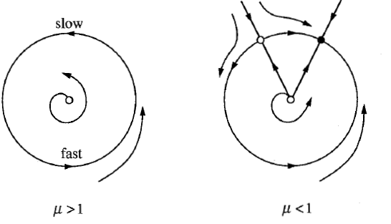

As decreases, the limit cycle r=1 develops bottleneck at =/2that becomes increasingly severe as 1+.The oscillation period lengthens and finally becomes infinite at c=1, when a fixed point appears on the circle; hence the term **infinite-period bifurcation**.

**Homoclinic Bifurcation**

* In this type of bifurcation, part of a limit cycle moves closer and closer to a saddle point. At the bifurcation the cycle touches the saddle point and becomes a homoclinic orbit.
* Consider the equation:

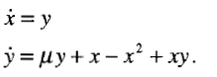

Numerically, the bifurcation is found to occur at c -0.8645. For <c, a stale limit cycle passes close to a saddle point at the origin. As increases to c,the limit cycle swells and bangs into the saddle, creating a homoclinic orbit. Once >c, the saddle connection breaks and the loop is destroyed.

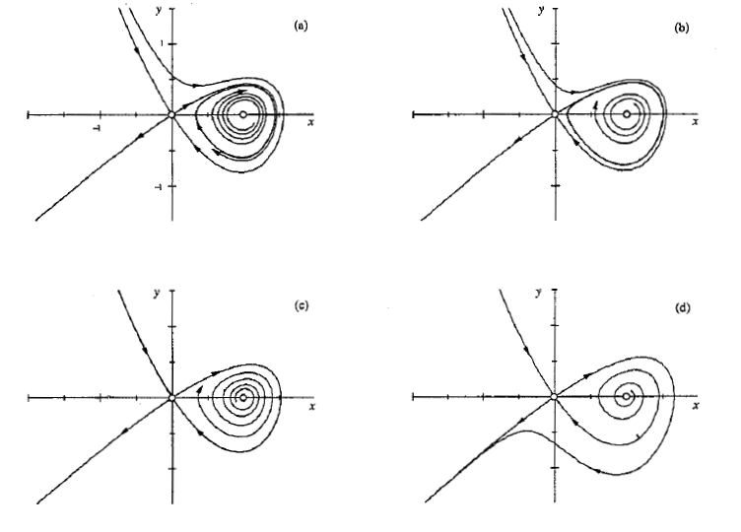

The key to this bifurcation is the behaviour of the unstable manifold of the saddle.

**Hysteresis in the driven pendulum and Josephson Junction**

In this section we will be dealing with a physical problem in which both homoclinic and infinite period bifurcation. For sufficiently weak damping the pendulum and the Josephson junction can exhibit intriguing hysteresis effects with integration of coexistence of a stable limit cycle and a stable fixed point.

Governing equations:

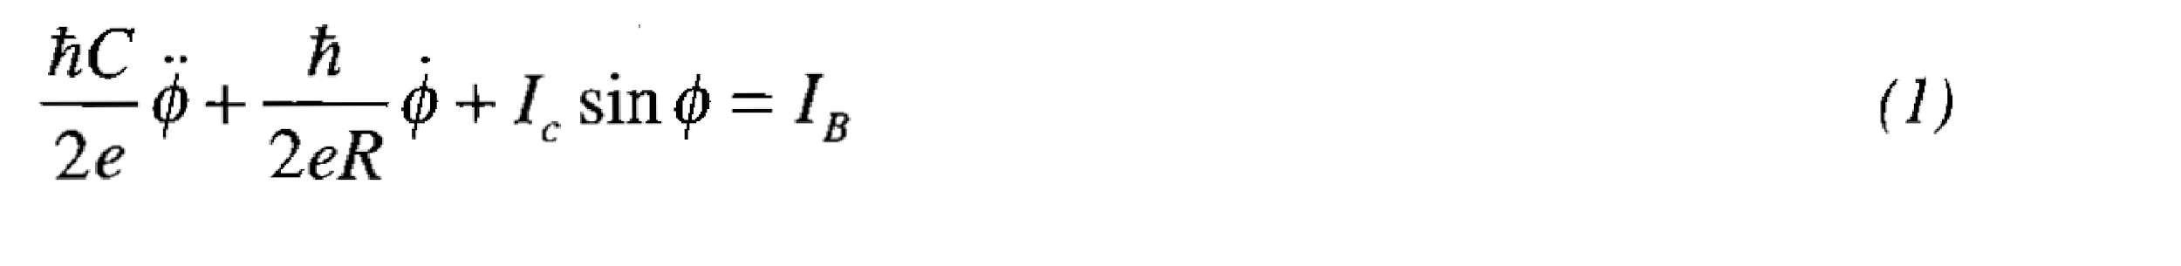

Here :

IB: constant bias current, C: junction capacitance,

R: resistance, Ic: critical current.

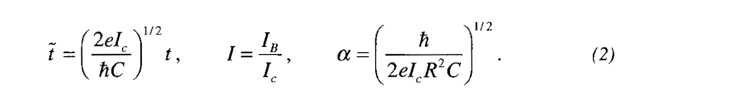

Now , equation (1) can be written in the form like this

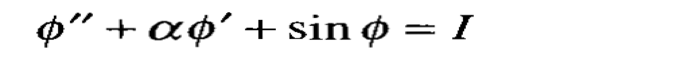

**Fixed Points**

The fixed point of (4) satisfy y*=0 and sin pi*=I. hence there are two fixed points on the cylinder if I<1, and none if I>1.

When the fixed point exist, so one is saddle and the other is a sink,s ince the jacobin.

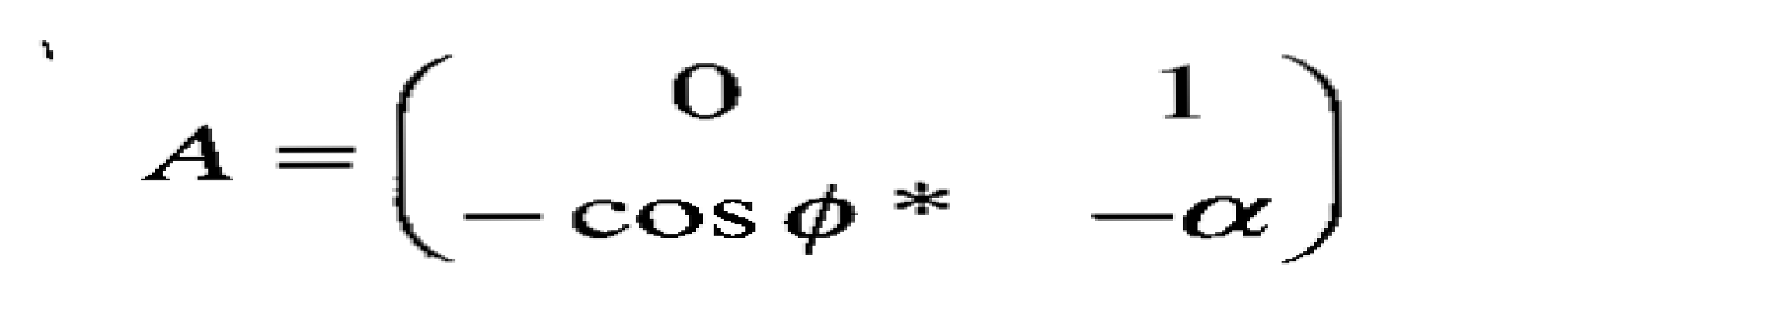

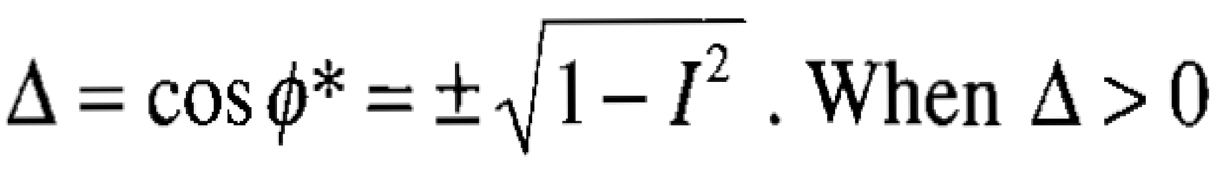

**Case 1.**

We have stable point if the damping is strong enough or if I is close to 1.

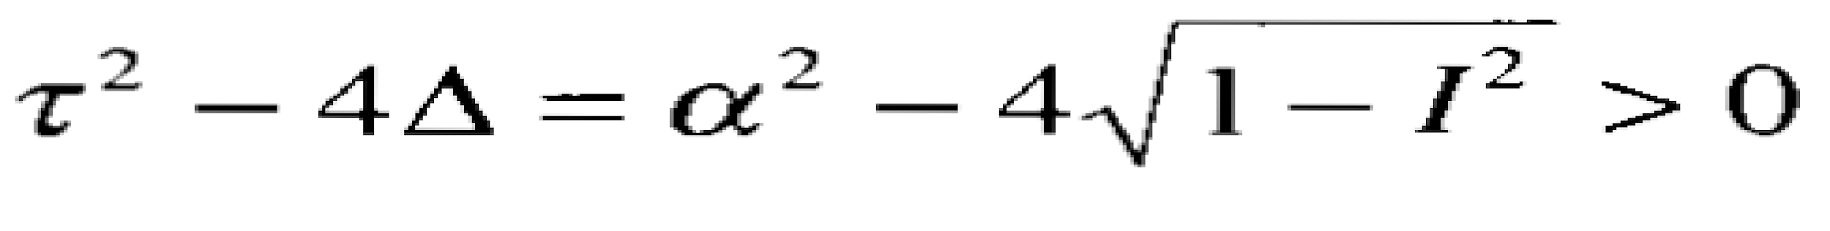

**Case 2**. Sink is a stable spiral. At I=1 the stable node and the saddle coalesce in a saddle-node bifurcation of fixed points.

**Librations and rotations**

There are two topological different kinds of periodic orbits on a cylinder.

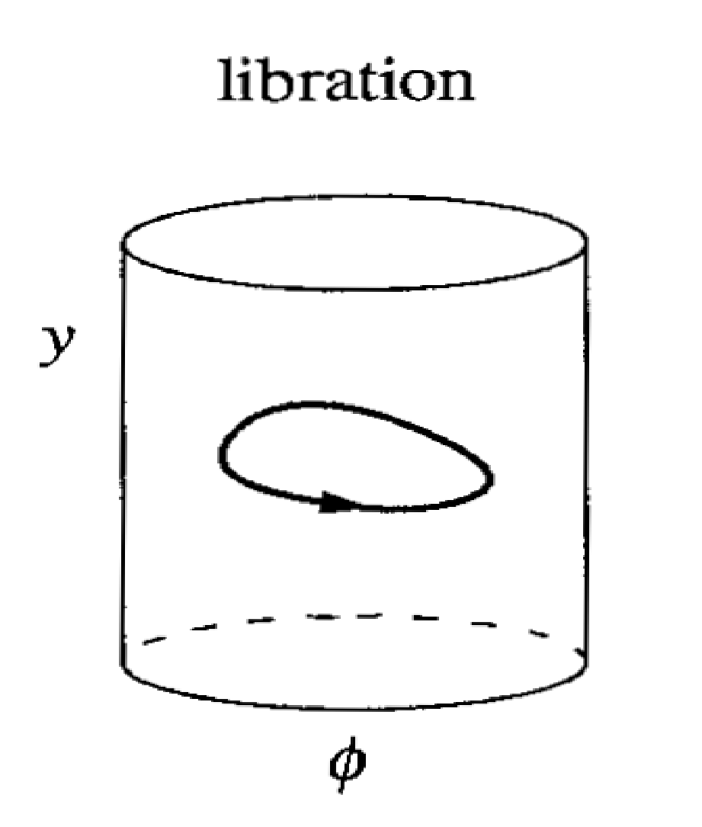 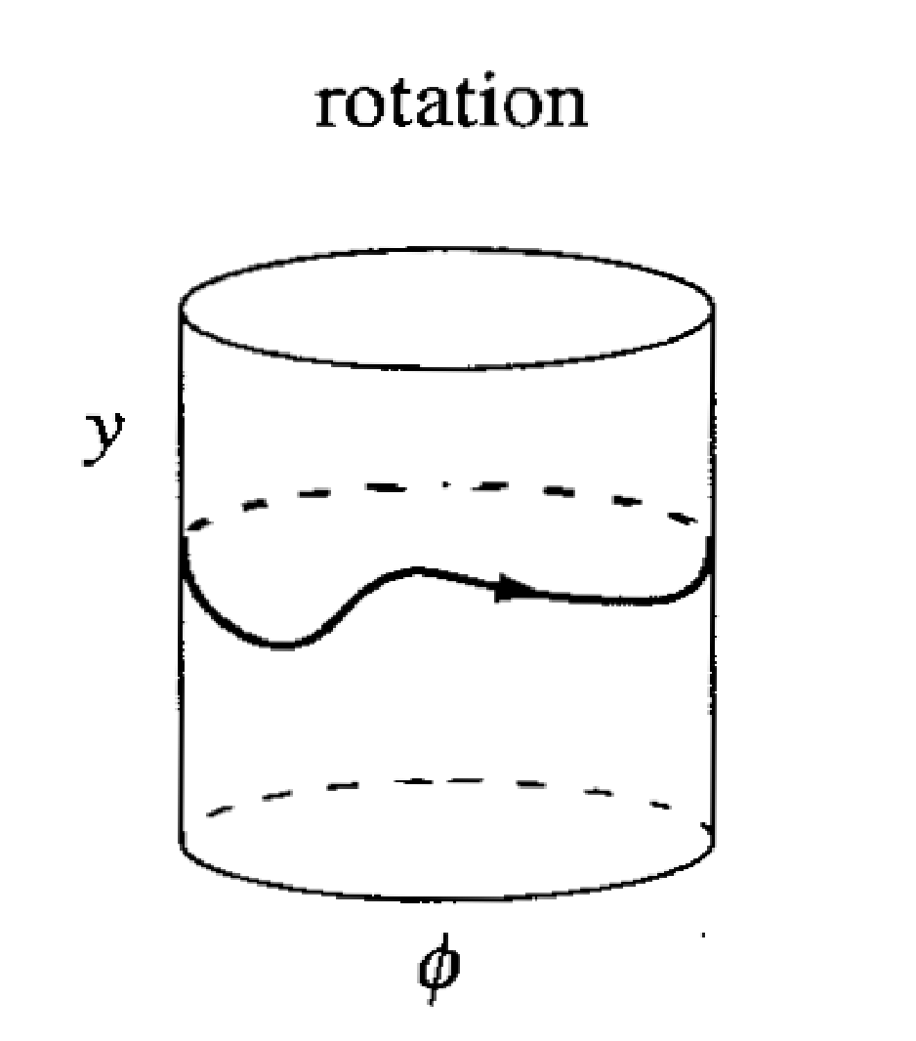

For I>1, librations are impossible because for any libration must encircle a fixed point by index theory. But there are no fixed points when I>1. Hence we only need to consider rotations.

Now let’s suppose we have two different rotations. Then the diagram of rotations of phases we look like.

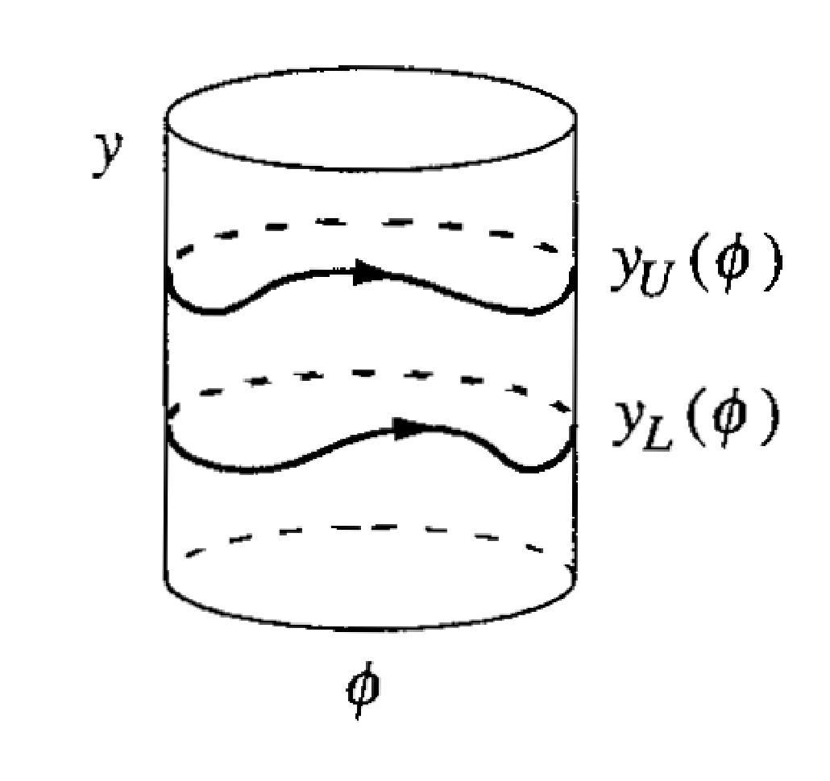

One rotations would have to lies strictly above the other because the two phase trajectory can’t cross over each other as shown in U and L above.

**Coupled oscillators and Quasiperiodicity.**

1. **Coupled oscillators**

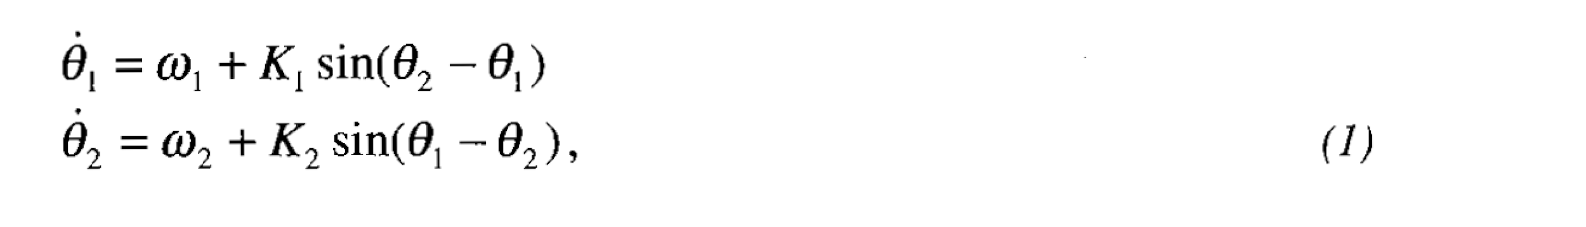

This model has been used to model the interaction between human circadian rhythms and the sleep-wake cycle (Strogatz 1986,1987).

**Compromise frequency**

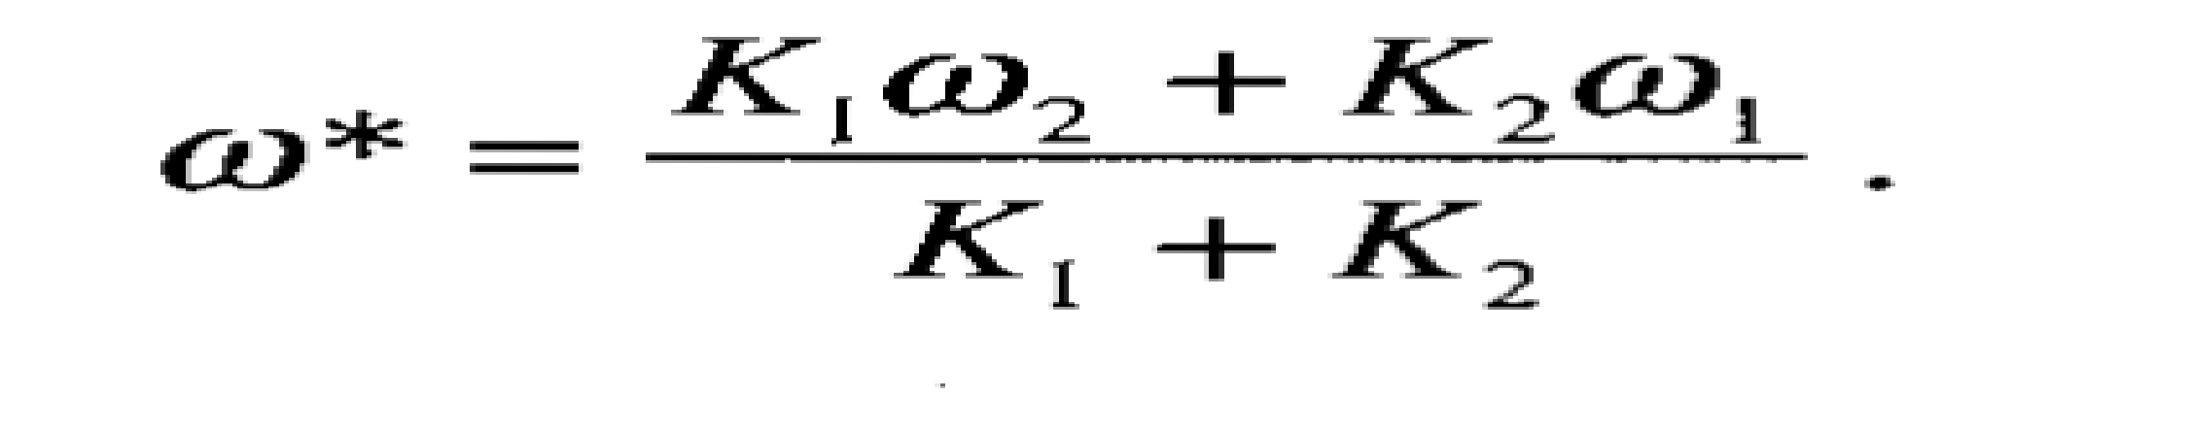

This frequency is called compromise frequency because it lies between the natural frequency of oscillators.

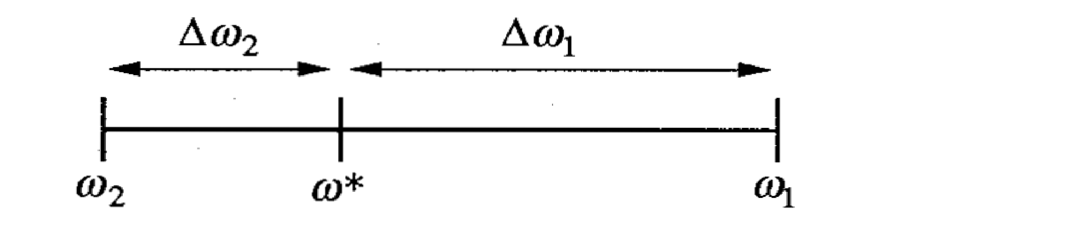

**Poincare Maps**

The Poincare map p is a mapping from s to itself, obtained by following trajectories form one intersection with S to the next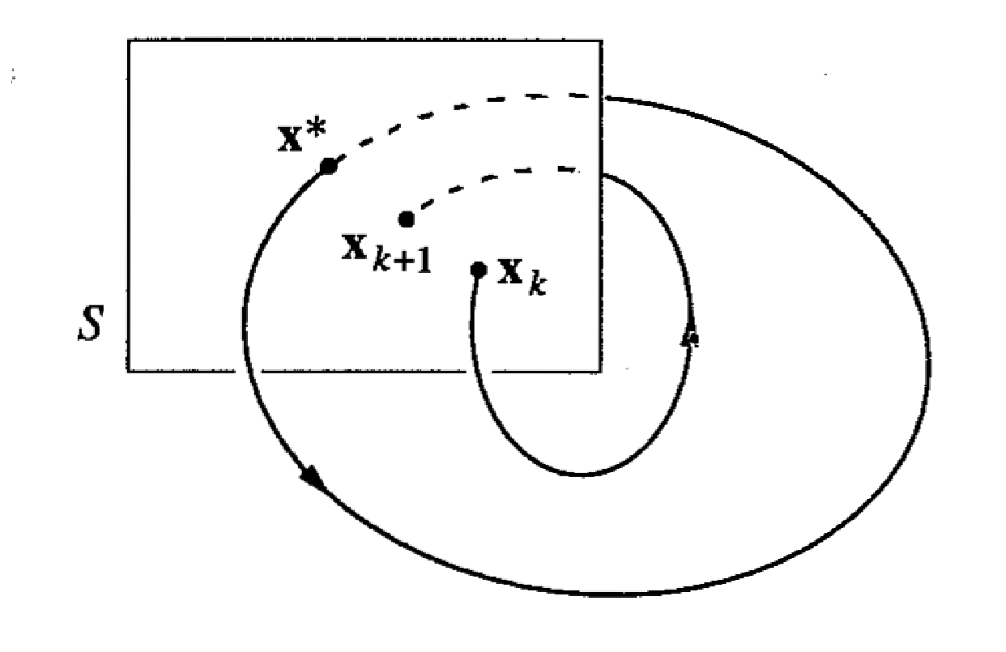

If Xk belongs to S denotes the Kth intersection, then the Poincase map can be defined as

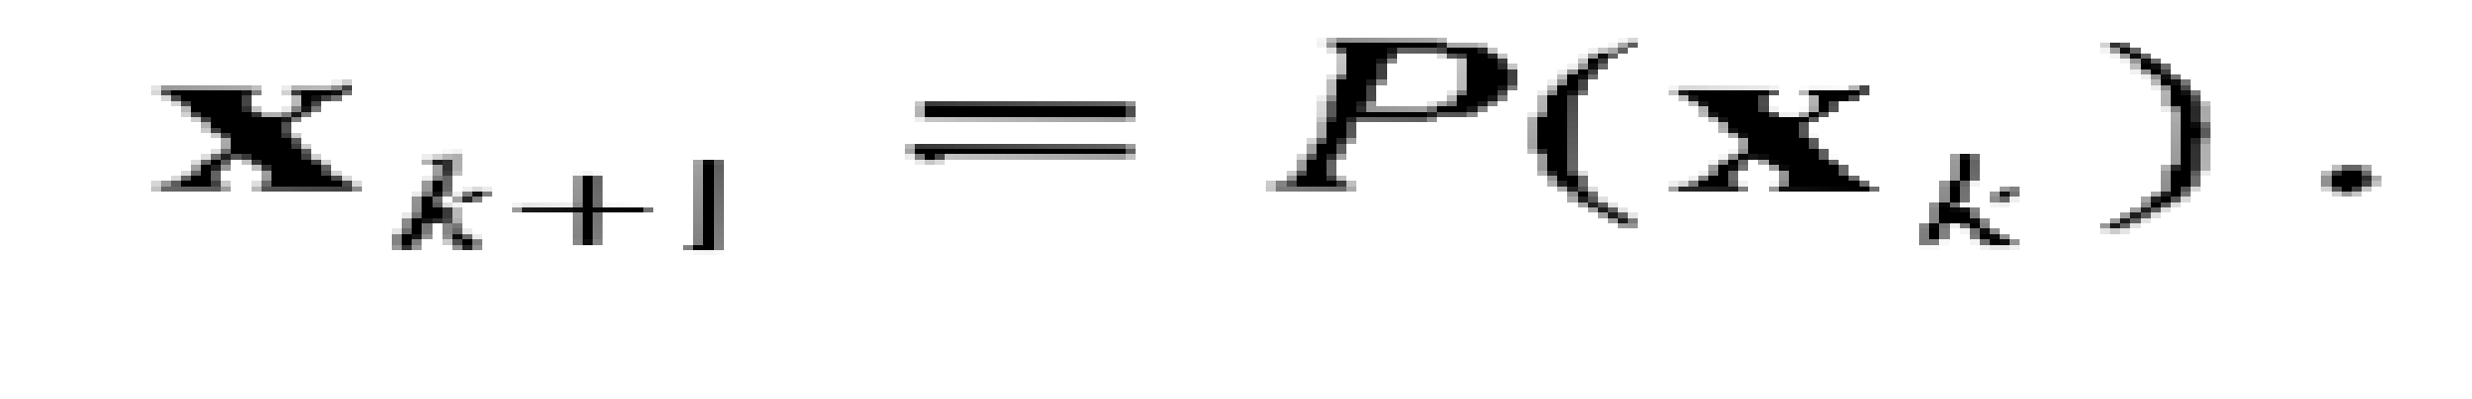

Thus using the Poincare map converts the problem about the closed orbit (which are different) into problems about the fixed points if a mapping( which is an easier in principle).